Estructura original del dataset
select * from tmpQESResults2025
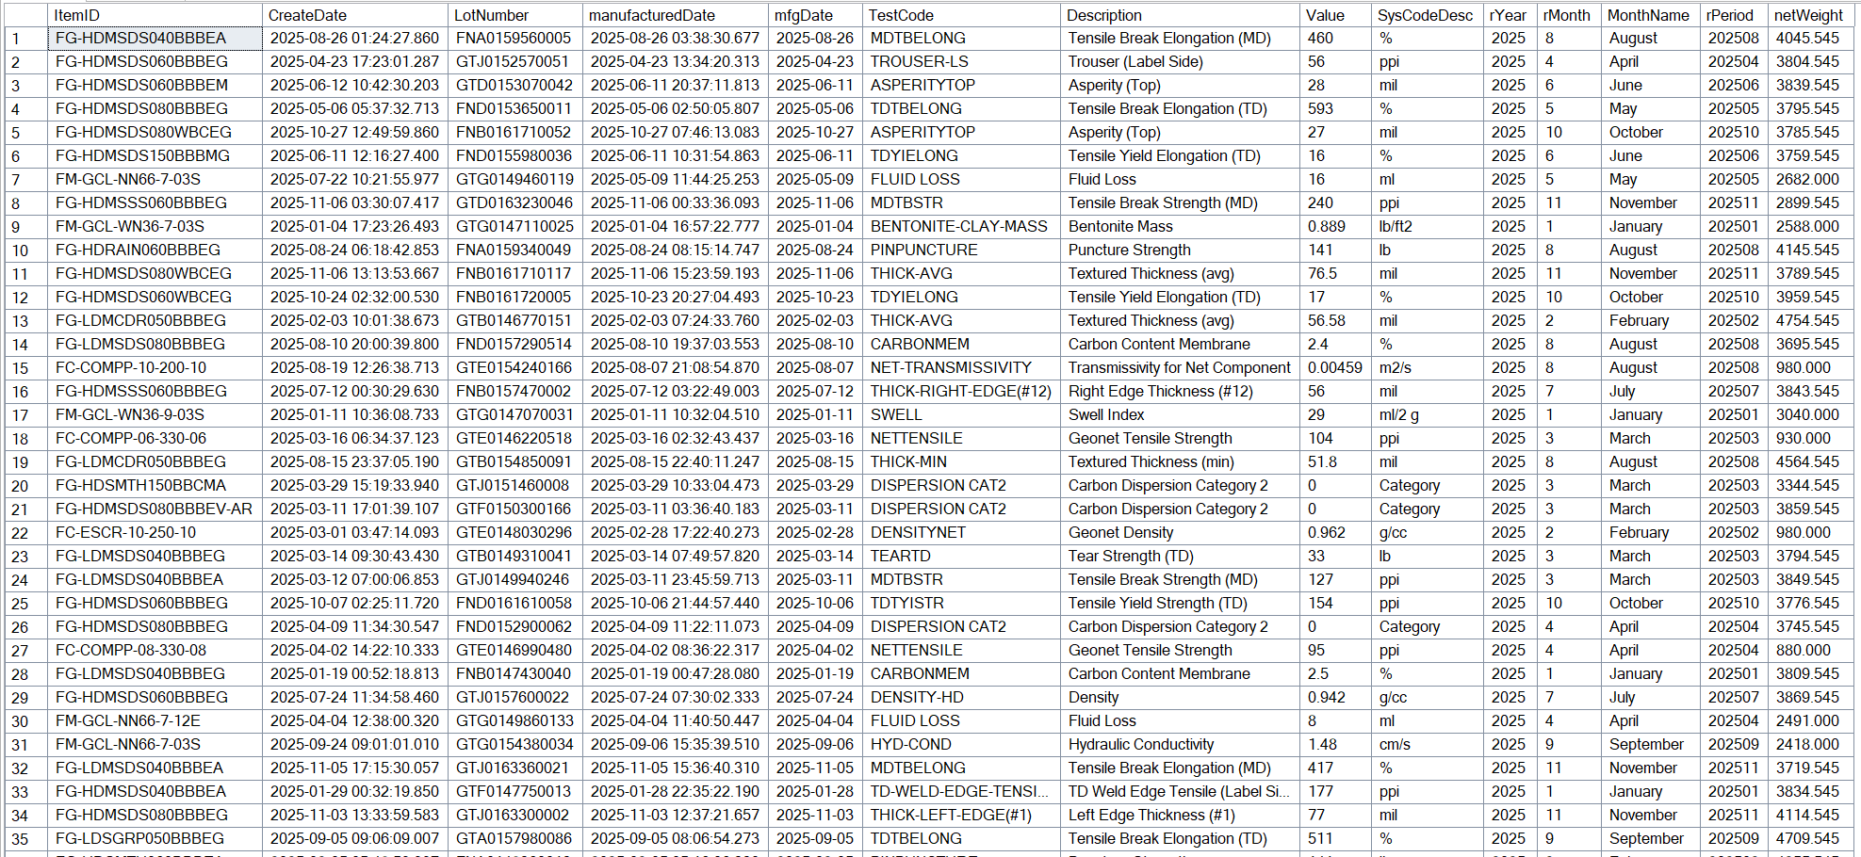

Delimitacion de pruebas para Items FG (Finished Geomembrane con resina de Alta Densidad HD)
select distinct TestCode from tmpQESResults2025 where ItemID like 'FG-HD%' and ItemID not in (select ItemID from HQMS_Items_1 where Description like '%smooth%')
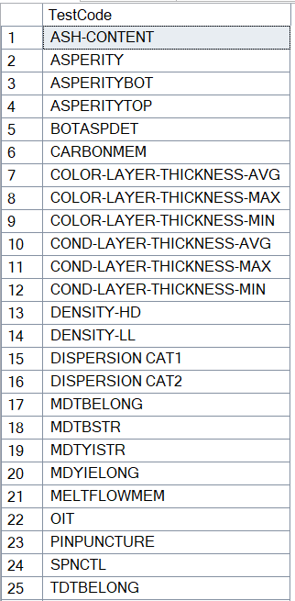
De la lista anterior se seleccionan como atributos las siguientes pruebas:
- [THICK-MIN]
- [THICK-AVG]
- [THICK-LEFT-EDGE(#1)]
- [THICK-RIGHT-EDGE(#12)]
- [ASPERITYBOT]
- [ASPERITYTOP]
- [CARBONMEM]
- [DENSITY-HD]
- [DENSITY-LL]
- [MDTBELONG]
- [TDTBELONG]
- [MDYIELONG]
- [TDYIELONG]
- [MDTBSTR]
- [TDTBSTR]
- [MDTYISTR]
- [TDTYISTR]
- [TEARMD]
- [TEARTD]
- [MELTFLOWMEM]
- [OIT]
- [PINPUNCTURE]

Convirtiendo los resultados en atributos de los lotos usando PIVOT para rotar la tabla
Se agrega un filtro adicional para filtrar por Items Double Sided exlcuyendo '%SSS%' Single Sided
Se filtran valores nulos para las pruebas the Grosor y Asperidad, para reducir valores no validos en el dataset
SELECT
ItemID, LotNumber, manufacturedDate,
[THICK-MIN],[THICK-AVG],[THICK-LEFT-EDGE(#1)] [THICK-LEFT-EDGE],
[THICK-RIGHT-EDGE(#12)] as [THICK-RIGHT-EDGE], [ASPERITYBOT], [ASPERITYTOP],[CARBONMEM],COALESCE([DENSITY-HD],[DENSITY-LL]) as DENSITY,[MDTBELONG],[TDTBELONG],[MDYIELONG],[TDYIELONG], [MDTBSTR],[TDTBSTR],[MDTYISTR],[TDTYISTR],[TEARMD],[TEARTD], [MELTFLOWMEM],[OIT],[PINPUNCTURE]
FROM
(SELECT ItemID, LotNumber, manufacturedDate, TestCode, Value
FROM tmpQESResults2025 where ItemID like 'FG-HD%' and ItemID not like '%SSS%' and Value is not null
) AS src
PIVOT(
MAX(Value)
FOR TestCode IN ([THICK-MIN],[THICK-AVG],[THICK-LEFT-EDGE(#1)],
[THICK-RIGHT-EDGE(#12)],[ASPERITYBOT],[ASPERITYTOP],[CARBONMEM],[DENSITY-HD], [DENSITY-LL], [MDTBELONG],[TDTBELONG],[MDYIELONG],[TDYIELONG], [MDTBSTR], [TDTBSTR],[MDTYISTR],[TDTYISTR],[TEARMD],[TEARTD],[MELTFLOWMEM],[OIT], [PINPUNCTURE])
) AS p
where [THICK-AVG] is not null and ASPERITYTOP is not null

